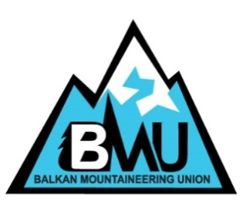

BALKAN MOUNTAINEERING UNION
Ul. 11 Oktomvri 42aweb: www.bmumagazine.com
1000 Skopje, R. of Macedoniae-mail: contact@bmumagazine.com
Tel./Fax: ++ 389 2 3165 540

Youth mountain festival
Prespa 2018
Republic of Macedonia

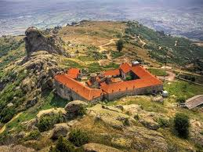 | 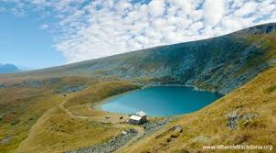 | 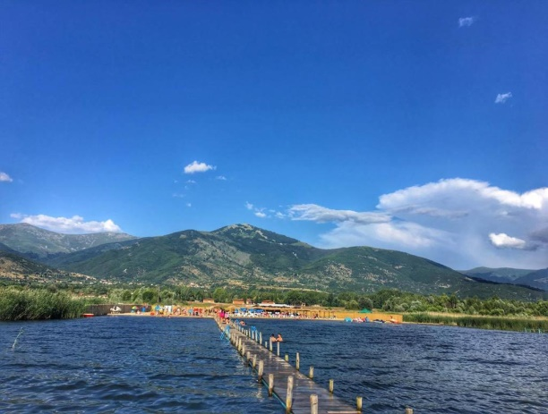

FPSM Youth Festival Program Timetable
Date | Time | Venue/Location
26.06  Tuesday | 12:00 – 17:00 | Arrival in Skopje, registration
 | 17:00 – 18:00 | Accommodation Matka/Vodno
 | 18:00 – 19:00 | Introduction to the Festival Program | 1 hour
 | 19:00 – 20.00 | Dinner
 | 20:00– 22:00 | Skopje tour

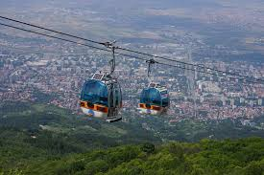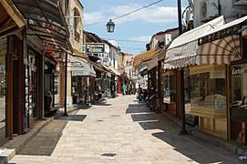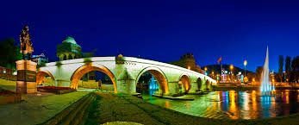

Date | Time | Venue/Location
27.06 | 07:00 – 07:30 | Breakfast
 | 07:30 – 9:30 | Trip to Prilep
 | 10:00 – 14:00 | Tour of the Prilep region: Zlatovrv, Treskavec Monastery
 | 15:00 – 16:00 | Lunch
 | 16:00 – 17:00 | Trip to Bitola, city tour, Molika
 | 19:00 – 20:00 | Trip to Prespa, hotel Krani, dinner
 | 20:00 – 21:30 | Presentations:  -Nature protection; Macedonian lynx  -GPS Orientation; mobile telephone GPS applications;on-site orientation | 2 х45 min.

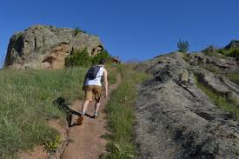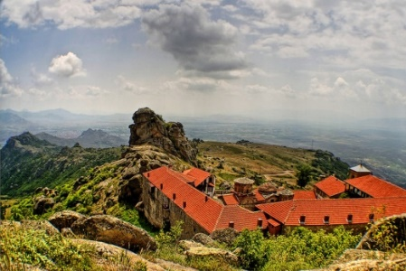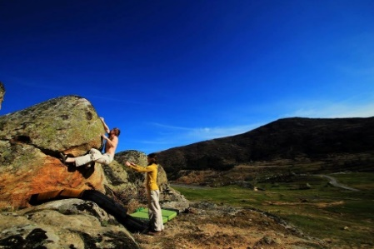

Date  28.06 | Time | Venue/Location
 | 06:00 | Pelister National Park
 | 17:00 –18:00 | Back trip to Krani, Prespa,  dinner

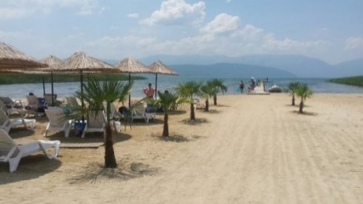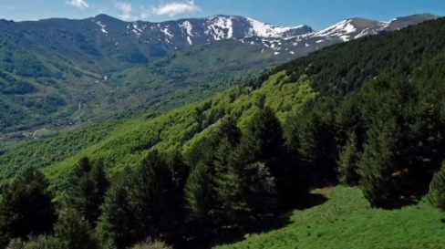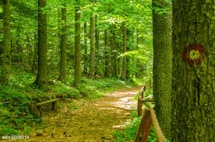

Date | Time | Venue/Location
29.06 | 07:00 – 07:30 | Breakfast
 | 07:30 – 14:00 | Hiking: Magaro Galicica national park
 | 14:30 – 15:30 | Ohrid - lunch
 | 16:00 – 19:30 | Ohrid- tour
 | 19:30 – 20:30 | Dinner
 | 20:30 – 21:30 | Mountain first aid | 1 hour presentation

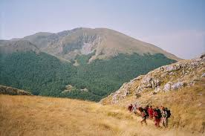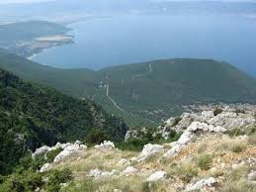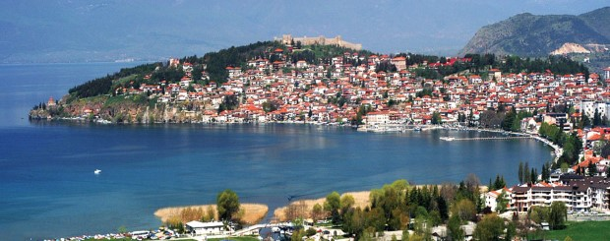

Date | Time | Venue/Location
30.06 | 07:00 | Breakfast
 | 08:30 – 14:00 | Trip to the villages of Lubojno and Brajcino
 | 14:00 – 16:00 | Lunch
 | Од 20:00 | Dinner and Festival closing in Resen
 | Од 22:00 | Closing party

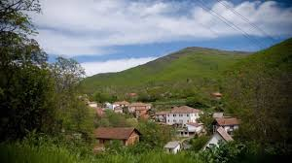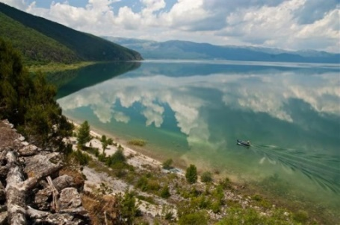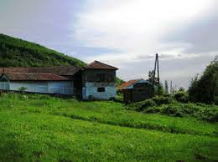

Date | Time | Venue/Location
01.07 | 07:30 – 08:00 | Breakfast
 | 08:00 – 11:00 | Trip to Skopje, Demir Kapija
*The weather conditions and other objective reasons can affect the Program

Hiking checklist: backpack (40 liter), waterproof jacket & trousers, hiking boots, personal sanitary supplies, personal first aid kit, head torch, hat+gloves, sun glasses, trekking poles.

Youth Festival general conditions:
- Total number of participants 30 (3 participants from each federation)

- Age: 17-23.
- Mountain club membership registered in the mountain federation.

Registration deadline: 15.06.2018

Participation fees: 178 euro (accommodation, food and transport during the camp)

Other:
- Full board in the Mountain house Matka-Skopje and Krani-Resen
- Transport organized by FPSM
- FPSM mountain guides

Contact: FPSM office tel. +3893165540, mob. +38970777043
contact@fpsm.org.mkc

REGISTRATION FORM
Youth mountain festival
Prespa 2018
Republic of Macedonia

FEDERATION:

address:

Phone: Fax: ______/___________________

E-mail:

PARTICIPANT:
Name and Family Name |  |  |  |  |  |  |  |  | Sex
Date of Birth |  |  | Email
Address
Telephone |  |  | Fax
Mobile telephone
Emergency home contact number
Passport number |  |  |  | Period of validity
Date of issuing and city
Please indicate your language preferences.
Spoken languages | 1. |  |  |  |  |  | 2.
Special diets: ◻ vegetarian ◻ Eat variety ◻ allergies and intolerances ◻ special diet

Details: It's Ortodox fasting time so I don't eat meat, eggs or any milk product

Do you have any Special medical needs or allergies that we should be aware of?

Name and telephone numbers of a person we can contact in the event of an emergency
Participant mountaineering experience:
◻ 1 year ◻ 3 year ◻ 5 year ◻ more...
If you have more participants, please use another copy of this form.

Place, date and time of arrival and transport, which you plan to use:

_______________________________________________________________

Question: ______________________________________________________

Date: Signature:

***Insurance: Participants should have a collective or individual insurance policy, which guaranties covering the expenses of the rescue operations if an accident happens to them in Macedonia. In addition third party liability, accident and travel insurance should be acquired. Please bring a copy of your insurance with you.
Name of the insurance company:
Policy number:
Others notes: ______________________________________________________

Participants applying for a Youth camp in Macedonia event also acknowledge and accept that:
- Safety is a primary concern, but as with all the other forms of climbing there is a danger of personal injury or death;
- Participants, accept the risks of participation and are responsible for their own actions, which should take account of relevant circumstances such as changing weather conditions.
- To take part it is necessary to be medically fit to do the activity and have valid liability and accident insurance which is valid in the country of the event and which covers rescue and repatriation. Please bring a copy of your insurance with you to show the organizers
Signed (Participant) Date:

